**Internship Weekly Report – Week 1**

**🔹 Title Page**

* **Name:** Sandeep Ravaji Patel
* **Domain:** Data Science
* **Week Number:** Week 1

**🔹 Task Description**

**Objective:**  
To get started with Python programming and develop a foundational understanding through basic syntax, control structures, functions, and data structures.

**Tasks Completed:**

1. **Python Basics Practice:**
   * Data types (integers, strings, lists, dictionaries).
   * Conditional statements (if, elif, else).
   * Loops (for, while) for iteration.
   * Functions: User-defined functions and function arguments.
2. **Data Manipulation Tasks:**
   * Worked with lists and dictionaries to store and process structured data.
   * Implemented tasks like counting word frequency, grouping data, filtering values, and performing lookups.
3. **Notebook 1 – Basic Programming:**
   * Wrote programs to print palindromes, Armstrong numbers, and calculate power using functions.
   * Practiced number analysis (sum/count of digits, etc.).
4. **Notebook 2 – Data Manipulation:**
   * Created mini applications using lists and dictionaries.
   * Examples: Contact book, student marks analysis, employee grouping.

**🔹 Code Snippets / Design Screenshots**

Example: Palindrome Number Function

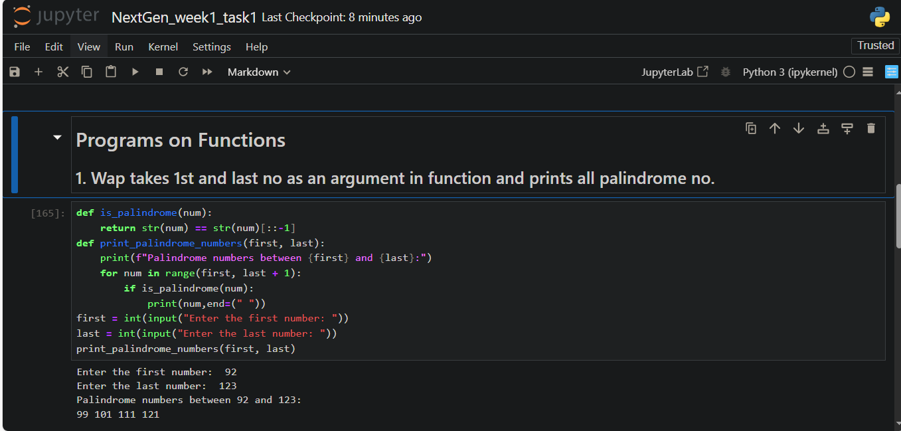

Example: Data Grouping with Dictionary

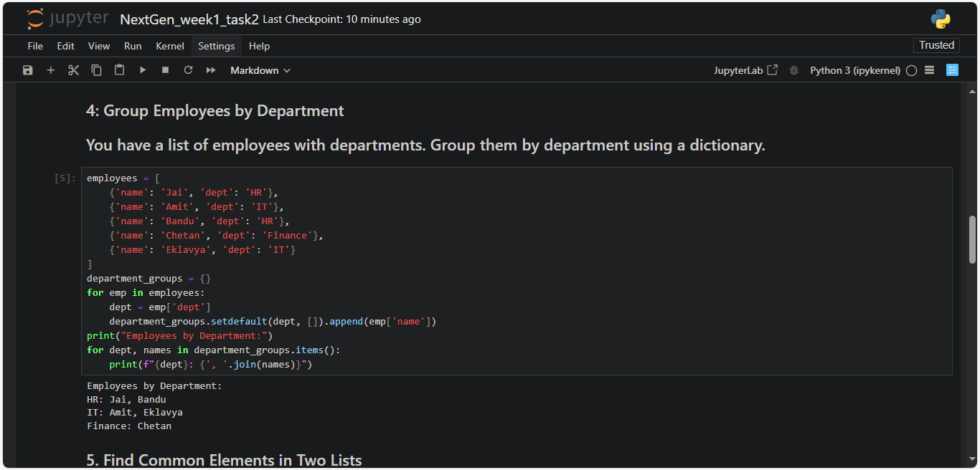

**🔹 Challenges Faced**

* Initially struggled with proper indentation in Python loops and conditionals.
* Faced confusion distinguishing between mutable and immutable data types (e.g., lists vs tuples).
* Minor issues using Google Colab and Jupyter for the first time, especially with markdown formatting and cell execution.

**How They Were Resolved:**

* Referred to W3Schools and official Python documentation for syntax and examples.
* Practiced writing short programs to reinforce understanding.
* Learned by debugging and reviewing error messages.

**🔹 Learning Outcome**

* Gained hands-on experience with core Python concepts.
* Learned how to manipulate and process basic data structures.
* Strengthened logical thinking and debugging skills.
* Understood the difference between writing a script and designing small problem-solving applications.

**🔹 Next Steps**

For **Week 2**, the focus will be on:

* Learning data handling using **Pandas** and **NumPy**.
* Performing operations like filtering, grouping, and sorting on datasets.
* Working with real-world CSV/Excel files.